Compiler warnings in ara::diag code

Ticket Num - AR-112197 :-

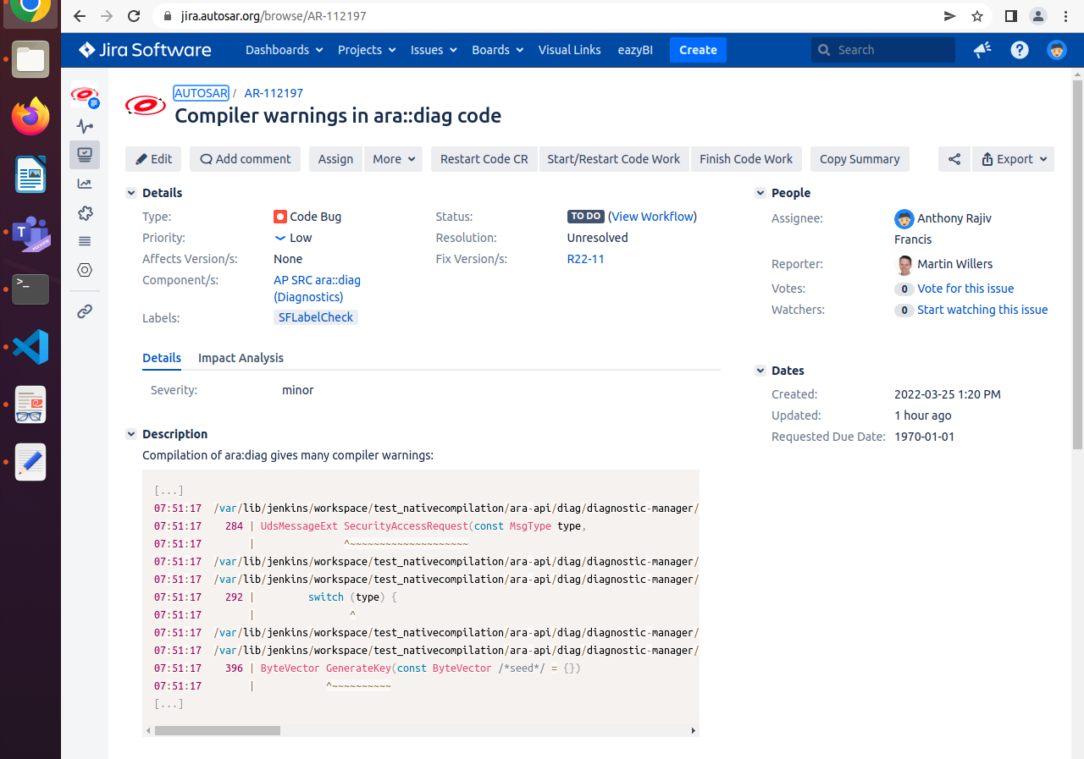

1. /mnt/diag/diagnostic-manager/src/test/dcm/security_access_test.cpp:284:15: warning: no previous declaration for ‘ara::diag::uds_transport::UdsMessageExt ara::diag::dcm::service::SecurityAccessRequest(ara::diag::dcm::service::MsgType, ara::core::Optional<unsigned char>, ara::diag::uds_transport::ByteVector)’ [-Wmissing-declarations]
284 | UdsMessageExt SecurityAccessRequest(const MsgType type,
We added the function prototype for UdsMessageExt SecurityAccessRequest(const MsgType type, function as static in async_handler_service.cpp line number 284.
Static function : Static function are visible in the file where it was declared.It means we cannot call that function in other cpp file.we have several static function named in several source files.
Insted of declaring function as static we can declare the function in header file also.But why we are not adding in header file means it is not nesseary to declare the function in header file.Because the scope of the function is required only in that cpp file we don’t need that in other files.

2. /mnt/diag/diagnostic-manager/src/test/dcm/security_access_test.cpp:292:16: warning: switch missing default case [-Wswitch-default]
292 | switch (type) {
We added default condition std::abort() in file security_access_test.cpp line number 308-309.
std::abort()-it will terminate the program once sigabert is being caught by a signal handler.
Sigabert : It is used to terminate the running processes.

Insted of std::abort we can use the following methods:

- std::exit() - causes normal program termination with cleaning up.
- std::quick_exit() - Causes normal program termination to occur without completely cleaning the resources.
- std::terminate() - function called when exception handling fails .

Why we are not using above functions :

- It does not properly shutdown other threads (they just get terminated), it does not properly flush all buffers.
- It cannot release memory allocated at runtime.

The difference between exit and abort is that exit allows the C++ run-time termination processing to take place (global object destructors get called), but abort terminates the program immediately.

3. /mnt/diag/diagnostic-manager/src/test/dcm/security_access_test.cpp:396:12: warning: no previous declaration for ‘ara::diag::uds_transport::ByteVector ara::diag::dcm::service::GenerateKey(ara::diag::uds_transport::ByteVector)’ [-Wmissing-declarations]
396 | ByteVector GenerateKey(const ByteVector /*seed*/ = {})
We added the function prototype for function ByteVector GenerateKey(const ByteVector /*seed*/ = {}) as static in file security_access_test.cpp line number 398.
Static function : Static function are visible in the file where it was declared.It means we cannot call that function in other cpp file.we have several static function named in several source files.
Insted of declaring function as static we can declare the function in header file also.But why we are not adding in header file means it is not nesseary to declare the function in header file.Because the scope of the function is required only in that cpp file we don’t need that in other files.
4./mnt/diag/diagnostic-manager/src/libdcm/service/processors/0x27_security_access_config.cpp:88:85: warning: passing ‘short unsigned int’ chooses ‘int’ over ‘unsigned int’ [-Wsign-promo]
88 | ("SOME/IP:"std::to_string(item.second.get<uint16_t>("instanceId"))).c_str()};

we changed ‘unsigned int’ to ‘int’ in file 0x27_security_access_config.cpp

